Course Six

The Nuts and Bolts of Machine Learning


Instructions
Use this PACE strategy document to record decisions and reflections as you work through the end-of-course project. As a reminder, this document is a resource that you can reference in the future and a guide to help consider responses and reflections posed at various points throughout projects.

Course Project Recap
Regardless of which track you have chosen to complete, your goals for this project are:
- Complete the questions in the Course 6 PACE strategy document
- Answer the questions in the Jupyter notebook project file
- Build a machine learning model
- Create an executive summary for team members and other stakeholders

Relevant Interview Questions
Completing the end-of-course project will empower you to respond to the following interview topics:
- What kinds of business problems would be best addressed by supervised learning models?
- What requirements are needed to create effective supervised learning models?
- What does machine learning mean to you?
- How would you explain what machine learning algorithms do to a teammate who is new to the concept?
- How does gradient boosting work?

Reference Guide:
This project has seven tasks; the visual below identifies how the stages of PACE are incorporated across those tasks.
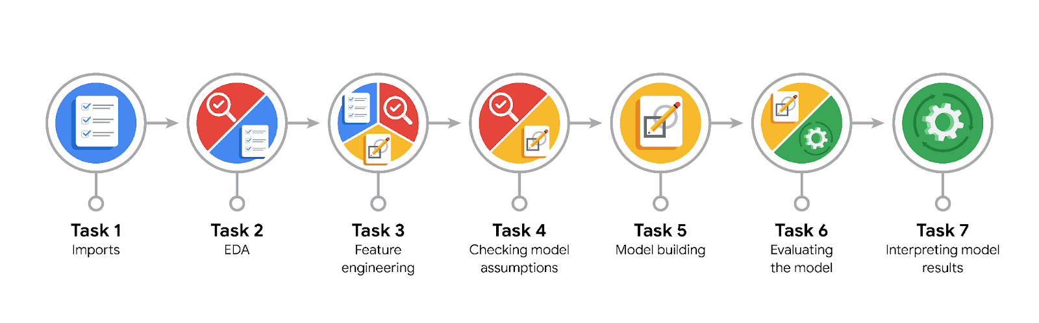

Data Project Questions & Considerations
PACE: Plan Stage
- What are you trying to solve or accomplish?
Construct a ML model with best scores to predict whether or not a Waze user is retained or churned.

- Who are your external stakeholders that I will be presenting for this project?
Managerial Team who will decide based on the findings of the data team.

- What resources do you find yourself using as you complete this stage?
- Dataset provided by the data team. - Jupyter notebook
- Python ML libraries

- Do you have any ethical considerations at this stage?
FN are very critical for us, because we do not want to miss any potential churning users, hoping to maximize retention. On the other hand, FP may not be very critical, as it may not be a big problem to identify a loyal user as churned. At worst, we may proactively provide offers for users predicted as churns, which may not have a huge negative impact on actually retained users.

- Is my data reliable?
It’s verified by the data team that the data source is valid.
Also, based on EDA on the data, it looks valid after handling outliers, missing values, or other discrepancies.

- What data do I need/would like to see in a perfect world to answer this question?
- A data with no missing value and outliers, as well as containing many related features.

- What data do I have/can I get?
- Current data contain some irrelevant values but it is still comprehensive enough.

- What metric should I use to evaluate success of my business/organizational objective? Why?
- Since False Negatives are critical to be minimized, recall score would be the most important matric to evaluate our classification process.

PACE: Analyze Stage
- Revisit “What am I trying to solve?”Does it still work? Does the plan need revising?
- We’re extracting more relevant features to address the quest of prediction whether a user churns or retains.

- Does the data break the assumptions of the model? Is that ok, or unacceptable?
- Hopefully Random-Tree-based and boosting models require no specific assumption on the data. So they’re perfectly applicable to our case.

- Why did you select the X variables you did?
X = df[['sessions', 'drives', 'total_sessions',
'n_days_after_onboarding', 'total_navigations_fav1','driven_km_drives',
'duration_minutes_drives',
'activity_days', 'driving_days', 'km_per_driving_day',
'percent_sessions_in_last_month', 'professional_driver',
'total_sessions_per_day', 'km_per_drive']]
We dropped `device` as we saw in the EDA that it has no significant effect on the churn.
- What are some purposes of EDA before constructing a model?
To ensure the data is well-structured, in proper dtypes, handling outliers and missing values.

- What has the EDA told you?
- `device` has no meaningful effect on churns
- Looks like professional drivers, in different senses, are more likely to churn. That is why we extracted new features in X.
- Some important features were producing inf values and needed to be imputed.

- What resources do you find yourself using as you complete this stage?
Pandas and matplotlib package to complete EDA and sklearn to preprocess the data to be fit by an ML model.

PACE: Construct Stage
- Do I notice anything odd? Is it a problem? Can it be fixed? If so, how?
Nothing in particular

- Which independent variables did you choose for the model, and why?
All features except device type look predictive. Hence it was left to random-tree-based models how to split on features.
- How well does your model fit the data? What is my model’s validation score?
Good validation scores with respect to our main criteria, which is “recall” score, as we would like to minimize the number of churned users whom the model identifies as retained.
Hence with a tradeoff with “precision” score, about 18% “recall” score was achieved, which is a great growth from logistic regression which gave us only 8%.

- Can you improve it? Is there anything you would change about the model?
There is always a way for improvement by tuning hyperparameters with the expense of computational power. But current prediction seems satisfying as ‘accuracy’ and ‘recall’ scores (even ‘precision’) are sufficiently acceptable.

- What resources do you find yourself using as you complete this stage?
Python packages such sklearn, xgboost, and pickle to build, reproduce and reuse ML models.

PACE: Execute Stage
- What key insights emerged from your model(s)? Can you explain the model?
- xgboost model predicts churned users with the best ‘recall’ score. Based on this model, top 10 features with the most importance on churning are as follows: duration_minutes_drives, n_days_after_onboarding, total_navigation_fav1, percent_session_in_last_month, driven_km_drives, total_sessions, km_per_driving_day, total_sessions_per_day, km_per_drive, and sessions (in last month).

- What are the criteria for model selection?
Validation scores such as ‘accuracy’, ‘precision’, ‘recall’ and ‘f1’ scores.

- Does my model make sense? Are my final results acceptable?
Xgboost model provides a relatively well recall score which is important not to misidentify actual churning users.

- Do you think your model could be improved? Why or why not? How?
More hyperparameter tuning can improve the model but not so much. In fact when recall increases, precision starts to decrease, and precision is already not very good.
Also more hypertuning may require more computational power.

- Were there any features that were not important at all? What if you take them out?
It doesn’t seem so. However EDA and hypothesis testing showed device type has no significant impact on churns. So we removed it from the model from the beginning.

- What business/organizational recommendations do you propose based on the models built?
Users with high driving times, those are long time users, and generally those with high values of the features mentioned above, shall be offered by ads or plans, so they refrain from churning.

- Given what you know about the data and the models you were using, what other questions could you address for the team?
Could we collect a larger dataset and more features?

- What resources do you find yourself using as you complete this stage?
Python notebooks and ML tools from sklearn and xgboost libraries.

- Is my model ethical?
- it accurately tries to remove bias and address the main goal by iterations and ensembling techniques.
- no PII are tracked throughout the study.

- When my model makes a mistake, what is happening? How does that translate to my use case?
There two types of mistakes:
- False Positives: actual retained users, whereas the model tagged them as churns.
- False Negatives: actual churned users, whereas the model tagged them as retention.
False Negatives are critical to be minimized, while False Positives may not be that important, as offering some plans to retained users in order to prevent churning, may not be critical at all.

